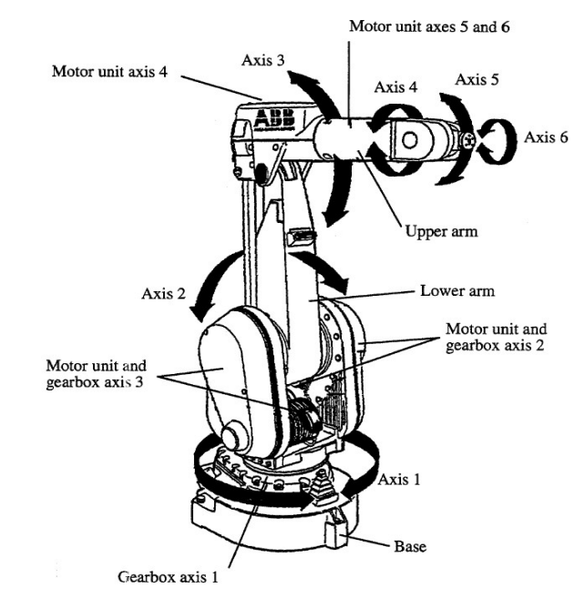

Figure 1: ABB IRB 1410 Industrial Robot.

Expt No:  06 | SERIAL MANIPULATOR ROBOT (ABB IRB 1410)
Date:
/ /2025

AIM:
To understand the manual and programmed control of a 6-axis serial manipulator (ABB IRB 1410) for a pick-and-place operation using the ABB FlexPendant.

APPARATUS REQUIRED:
- Robot: ABB IRB 1410 6-axis serial manipulator,
- Controller: ABB IRC5 Controller,
- Teach Pendant: ABB FlexPendant,
- End Effector: Pneumatic Gripper,
- Work Cell: Pegs and holder blocks, Safety interlocks.

THEORY / PRINCIPLE OF OPERATION:
The ABB IRB 1410 is a 6-axis serial manipulator. Its kinematic structure is an open chain of links connected by joints (like a human arm), where each joint adds a Degree of Freedom (DOF). It has 6 DOFs: the first three (J1-J3) generally position the wrist, and the final three (J4-J6) orient the end-effector.
- Coordinate Systems:
- Joint Space: Manually controlling each joint (J1-J6) independently. This is non-intuitive for the tool's position but is the robot's native control space.
- Cartesian/World Space: Commanding the Tool Center Point (TCP) to move in a straight line relative to the robot's fixed base (e.g., +X, +Y, +Z). The controller must solve the complex Inverse Kinematics (IK) equations to calculate the required angles for all 6 joints.
- Programming:
The method of "teaching" the robot by jogging it to a physical location and recording that point as a robtarget variable.
- Motion Instructions (RAPID):
- MoveJ (Joint Move): The fastest move. All joints move from their start to end angles simultaneously. The TCP follows a non-linear, unpredictable arc. Used for large, non-critical "free space" movements.
- MoveL (Linear Move): The TCP moves in a perfect straight line. The controller constantly re-calculates the IK solution. This is slower but essential for precise operations like approaching a part or welding.

PROCEDURE:
- Jogging (Manual Control):
    - Ensured the controller was in Manual Mode and gripped the FlexPendant, enabling the deadman switch.
    - From the ABB Main Menu, selected the Jogging window.
    - Selected "Axis 1-3" mode. Used the joystick to manually move Axis 1 (waist), Axis 2 (shoulder), and Axis 3 (elbow) individually.
    - Selected "Axis 4-6" mode. Used the joystick to manually move Axis 4 (wrist roll), Axis 5 (wrist pitch), and Axis 6 (flange roll).
    - Switched the jogging coordinate system to "Linear" mode. Moved the joystick in the X, Y, and Z directions.
    - Switched the coordinate system to "Re-orient" mode and manipulated the joystick to change the gripper's orientation.
    - Using a combination of Linear and Re-orient modes, the Tool Center Point (TCP) was carefully jogged to the "pick" position above the peg.

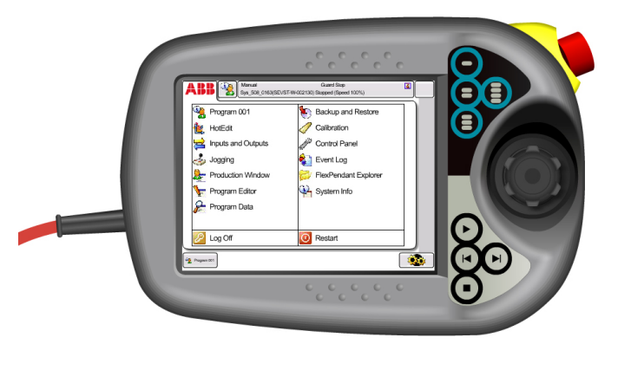

Figure 2: ABB Flex Pendent.

    - From the Main Menu, selected Input and Output. Manually toggled the d01 and d03 digital outputs to close the gripper and secure the peg.
    - Using "Axis" (joint) mode, the robot was jogged to a "safe" position high above the workspace.
    - Using "Linear" mode, the robot was jogged down to the "place" position.
    - The Input and Output menu was used again to toggle the d01 and d03 bits to open the gripper, releasing the peg.

- Programming (Automatic Control):
  - From the Program Editor, a new MainModule was created with a PROC MAIN.
  - The Add Instruction command was used to select a MoveL (Linear) instruction.
  - The robot was jogged to a "Home" position, and the Modify Position button was pressed to "teach" this location, creating a robtarget variable p1.
  - Set instructions were added for the gripper I/O to ensure it was open (SET DO1 HIGH, SET D03 LOW).
  - A MoveJ (Joint) instruction was added. The robot was jogged to an "approach" point above the peg, and the position was taught as p2.
  - A MoveL instruction was added. The robot was jogged slowly to the final "pick" position, and the position was taught as p3.
  - Set instructions were added to close the gripper (SET DO1 LOW, SET D03 HIGH).
  - Another MoveL was added to lift the peg straight up, taught as p4.
  - This process was repeated to teach an "approach_drop" point (p5), a "drop" point (p6), and the I/O commands to open the gripper.
  - The program was concluded with a MoveJ back to the p1 "Home" position.
  - The Debug tool was used to check for syntax errors. The Program Pointer (PP) was set to Main (Check simultaneously in the Pendent).
  - In Manual Mode at 50% speed, the program was executed step-by-step and then run continuously.

RESULT:
The manual jogging and programmed pick-and-place operations were successfully studied. The experiment provided a clear, practical understanding of the difference between joint-space (MoveJ) and linear-space (MoveL) motion, the "teach" programming method, and the integration of I/O (gripper) commands within an automated sequence on a 6-axis serial manipulator.

